7. Biochemical and bio-inspired power/energy systems Poster 0001
(please choose category from list) (if requesting poster) (reference number from
website confirmation)

PowerMEMS 2023 Sample Abstract and Instructions for Preparation

S. Ample¹ and A.B. Stract²
¹New York University, Abu Dhabi, UAE and ²Imperial College London, UK

The purpose of an abstract submitted to PowerMEMS 2023 is to tell the Technical Program Committee what new results you will present. It is important within the first few sentences to state what your primary results are. For example: “This paper reports the design, fabrication, and testing of a fully-integrated permanent-magnet turbine generator based on silicon MEMS fabrication technology.” It is also important to identify how the new work differs from previous work of your own group and of other groups. After an introduction of the basic ideas and how the work relates to other work, present detailed descriptions of methods, devices, and results, specifically stating whether they are experimental or theoretical. Figures and/or tables should support these results. After the presentation of results, it is useful to compare them with other work, discuss discrepancies or agreement, and comment on the broader impact.
The abstract is limited to two pages (US Standard 8.5 x 11 inches). The text is limited to no more than 500 words (please indicate the word count at the bottom of your abstract). Fonts should be Times New Roman 11pt with the exception of the title, which should be Times New Roman 14pt Bold. Figures and Tables should be collected on the second page with captions in Times New Roman 10pt Italic. Make sure that all figures and photos are clearly visible. If the program committee cannot clearly see and understand the role of the visual material included, the abstract likely will be viewed negatively. All drawings, photographs, and plots should be clearly labeled with appropriately sized fonts identifying the relevant components contained in the figure.
The header line with abstract category (chosen from the list below) and reference number, the title, authors (presenting author underlined), short affiliations, and all of the text must fit on the first page. Please place figures and tables on the second page. References (in short format) can go on either page. All abstracts, submitted on time, will be considered for both Oral and Poster Sessions unless specifically requested a poster presentation. This request should be on the header line as seen above. All abstracts are to be submitted in Portable Document Format (PDF) online via the PowerMEMS 2022 website. Abstracts will not be accepted via email, fax, or post. Once your abstract has been successfully uploaded, you will be sent a confirmation. The deadline to submit your abstract is Tuesday, 25 July 2023. No extensions will be made.

Word count: 499

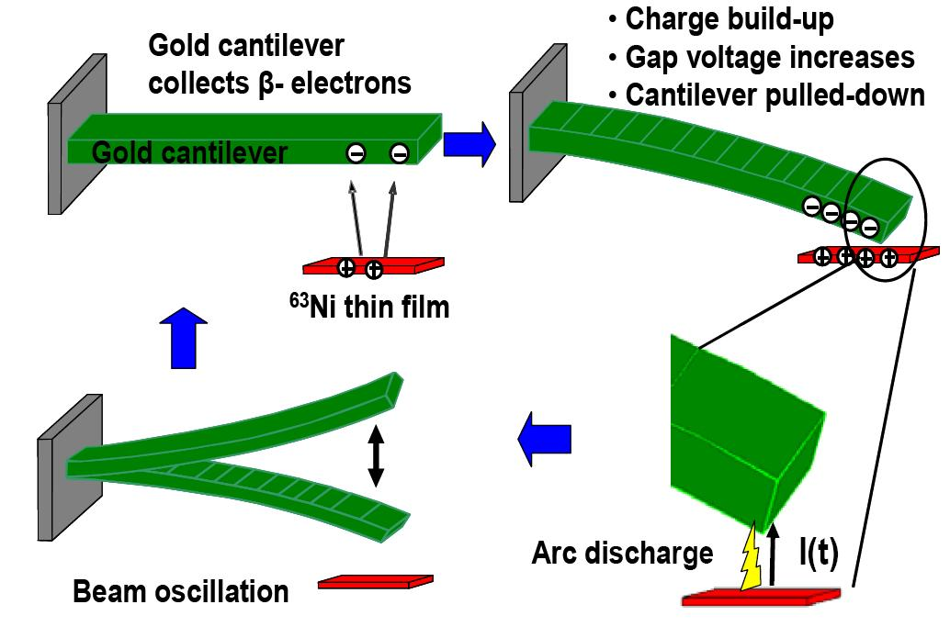
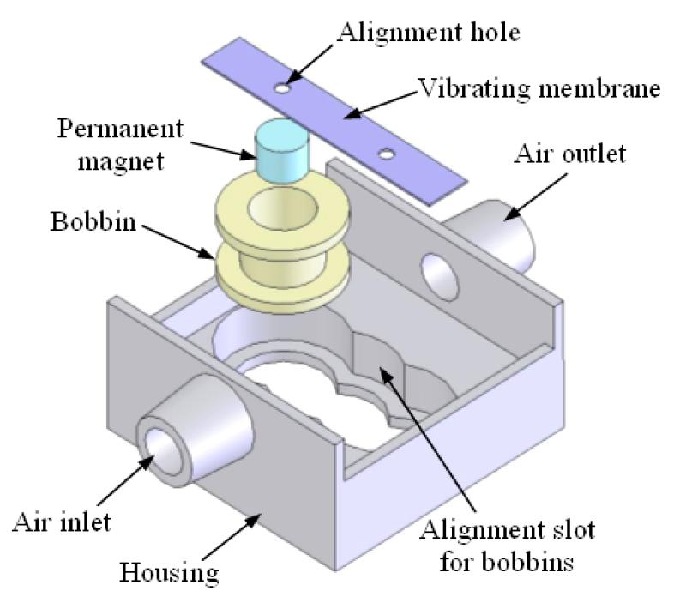
Figure 4. Example schematic clearly demonstrating a device operating principle.
Figure 1. Example of a device schematic with each component clearly labeled.
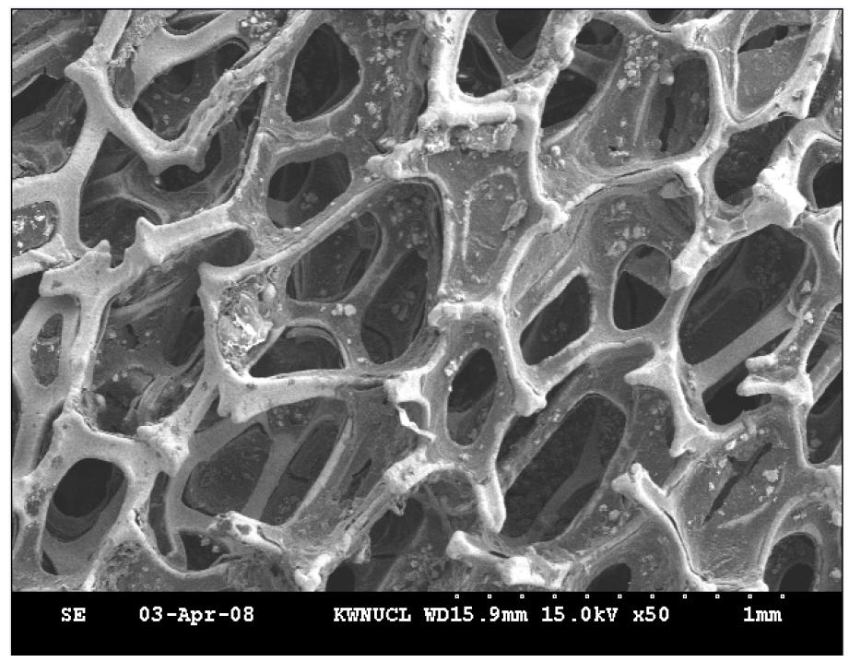
Figure 5. Example high-quality SEM photograph including scale bar.
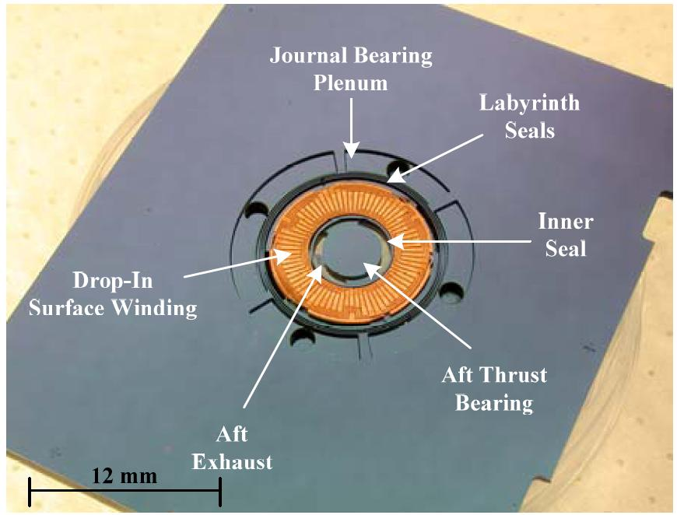
Figure 2. Example of a device photograph including scale bar and labeled components.

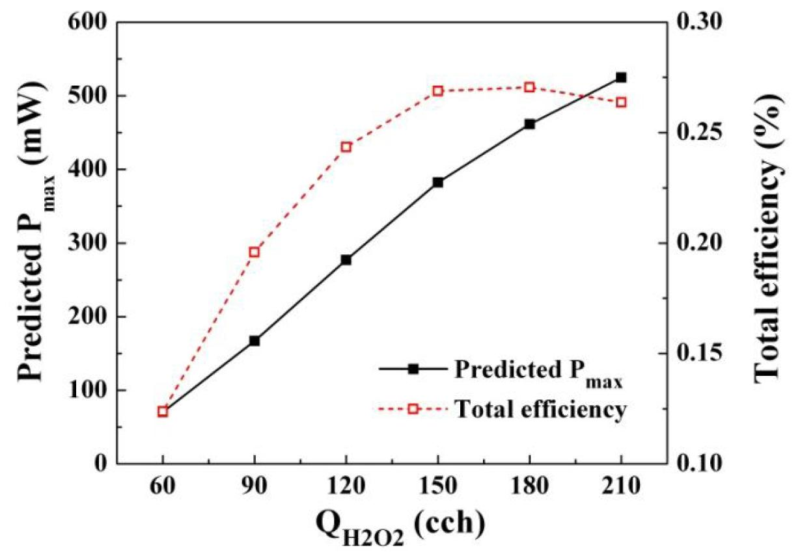
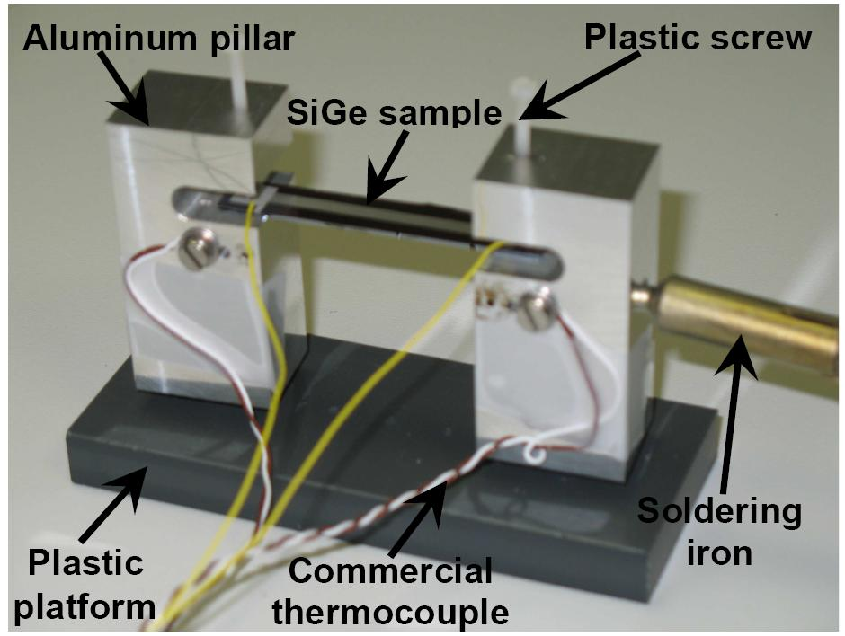
Figure 6. Example graph showing axes, values, labels, and units at an appropriate font size as well as clearly defined data points distinguishable in black and white.
Figure 3. Example photograph of an experimental setup with labeled device and components.

Submitting author: S. Ample, New York University, Abu Dhabi, P.O. Box 129188, UAE, Tel: +971-2-628-7046; Fax: +1-987-654-3210; E-mail: s.ample@place.edu
References
[1] S. Ample, Proc. MEMS 2022, pp. 100-103.
[2] S. Mart and S. O. Lution, J. Microelectromech. Syst., 23 (2015), pp. 300-315.

